**PROGRAMING GUIDE FOR SONOFF TOUCH**

1. **OPEN THE BOARD**
2. **TAKE OUT FRONT PORTION OF THE BOARD**
3. **MAKE CONNECTION WITH PROGRAMER LIKE THIS**

* The relays state can be set on the GPIO's 12, 5 and 4.
* The switch status can be read on GPIO's 0, 10 and 9. Push button active low.
* GND
* TXD
* RXD
* VCC
* To flash simply connect GND, TXD, RXD, and VCC, as a regular ESP. Hold the touch button, press reset at once, then it boots into flash mode.
* Stock baud rate: 74880

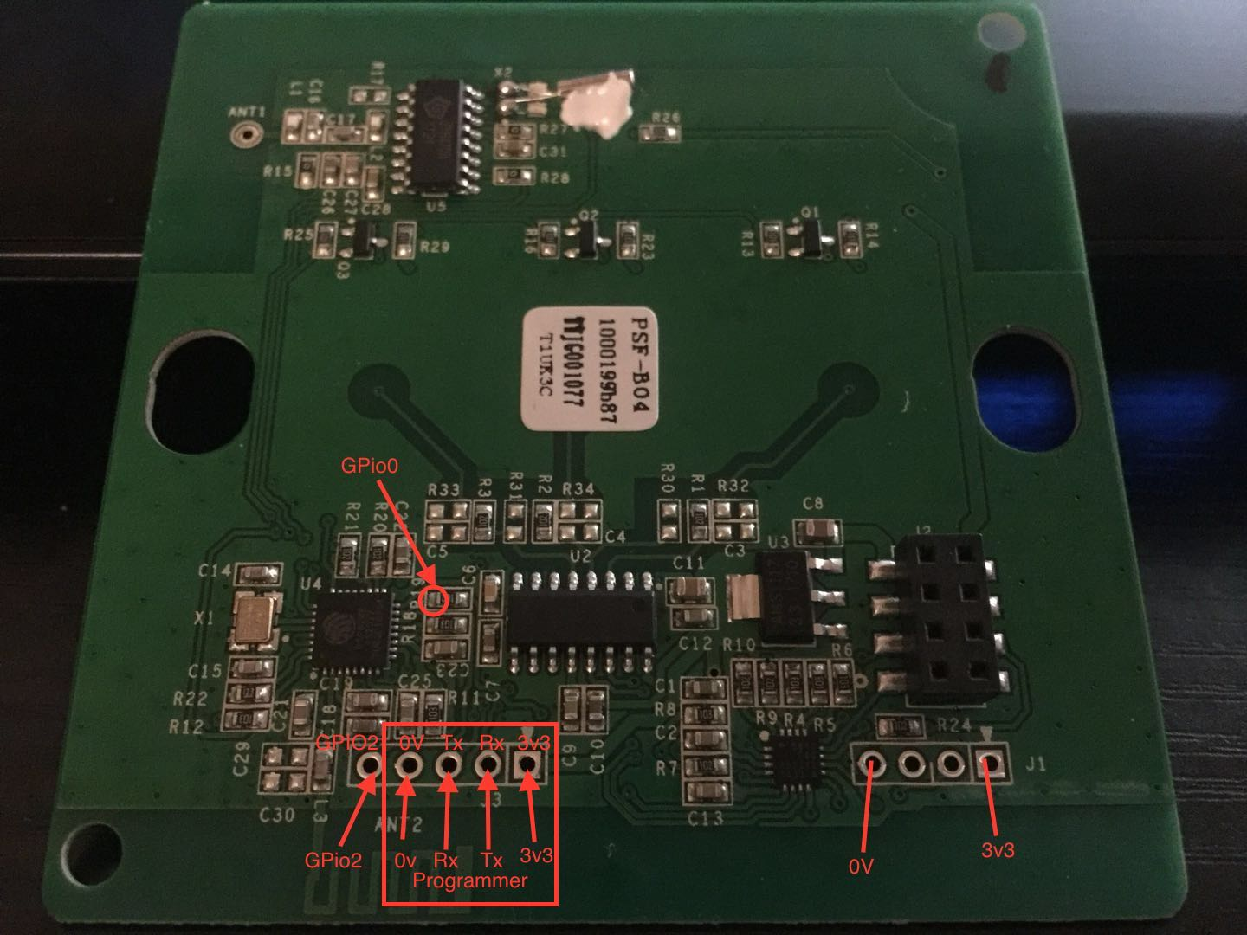

1. **FOR TAKING THE DEVICE INTO THE FLASHING MODE DO LIKE THIS:**

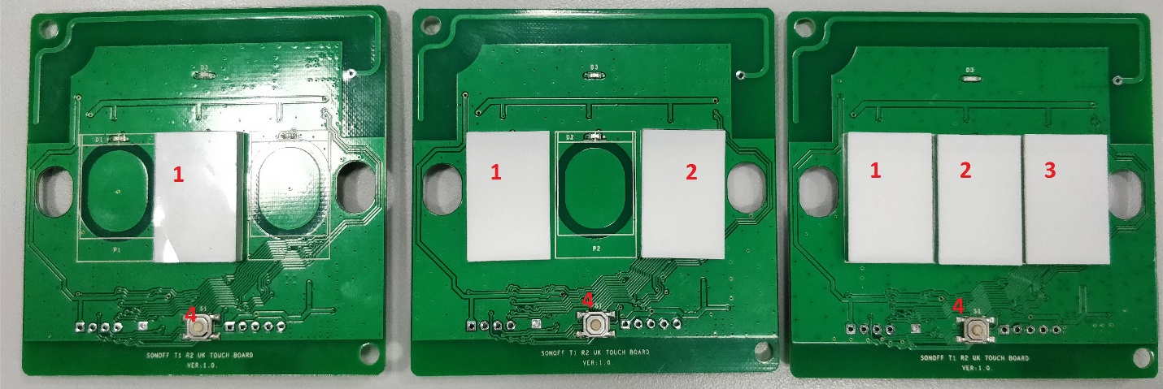

* The front circuit board should be disconnected from the rear relay board to prevent power draw upsetting the flashing process. The unit must be powered up before attempting to enter programming mode. If touch button 1 is held while power is connected, the ESP will not go into programming mode. The touch IC does not have time to recognize the key-press before the ESP boots.
* Entering Flashing mode varies between the 1 2 and 3 channel versions. See the above picture for button nomenclature used. (The variations between the 3 versions appear to be managed by the touch IC rather than in the ESP).
* To enter flashing mode the unit should be powered and connected to the programmer of choice. Touch Button 1 should then be held while the reset button (4) is pressed.
* This will cause the unit to reboot into flash mode. This is confirmed on a serial console (74880 baud) by the boot mode displaying (1,x) indicating that we are booted to the bootloader and not the flash. Button 1 can then be released. You can also confirm booted to flash without a serial console, the main led should be off and the backlight LEDs lit dimly.
* When using touch switch 1 : press touch when program is being upload.

**ESP8285 pin configuration:**

GPIO0 EFM8BB1 P1,3 Switch 1 input (Goes low when first touch button is pressed)

GPIO04 is connected to the small (soft) reset button on the front.

GPIO09 EFM8BB1 P1,4 - Switch 3 input (Goes low when third touch button is pressed)

GPIO10 EFM8BB1 P1,5 - Switch 2 input

GPIO13 is connected to status LED D3.

GPIO12 Relay 1

GPIO5 Relay 2

GPIO4 Relay 3

GPIO2 is connected on J3 pin 5 (LOG)

**On the EFM8BB1:**

P0,0 Relay 1

P0,1 Relay 2

P0,2 Relay 3

P0,3 Button 1

P0,4 Button 2

P0,5 Button 3

P0,6 SYN470R Data Out

P0,7 Relay protection?

P1,0 Led button 1

P1,1 Led button 2

P1,2 Led button 3

P1,3 ESP8285 GPIO0

P1,4 ESP8285 GPIO09

P1,5 ESP8285 GPIO10

P1,6 ESP8285 EXT_RSTB (RESET)